# Project Design Phase-I Solution Architecture

|  |  |
| --- | --- |
| Date | 12 October2023 |
| Team ID | NM2023TMID06068 |
| Project Name | Project – Globe Trek Insights Navigating Global Country Data With IBM Cognos |
| Maximum Marks | 4 Marks |

**Solution Architecture:**

* **Identify the data sources for global country data. These may include databases, data warehouses, external APIs, or flat files that contain information about various countries.**
* **Use ETL (Extract, Transform, Load) processes to gather and integrate data from multiple sources into a central repository. IBM DataStage, part of the IBM Cognos suite, can be used for ETL tasks.**
* **Store the integrated data in a data warehouse, which can be a part of your solution architecture or a separate component. IBM Cognos is often used with data warehouses like IBM Db2 or other relational databases.**
* **Use IBM Cognos Analytics to design reports, dashboards, and scorecards. You can create visually appealing and interactive content to help users access and analyze global country data.**

# Example - Solution Architecture Diagram:

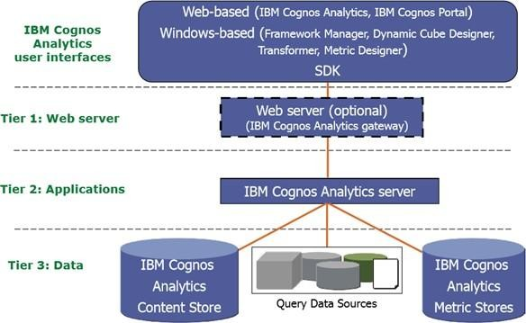

**Figure 1.1 solution architecture for Globe Trek Insights Navigating Global Country Data with IBM Cognos**